**PIZZA SALES SQL QUERIES**

1. **KPI’s**

**1. Total Revenue:**

**SELECT SUM(total_price) as TOTAL_REVENUE FROM pizza_new;**

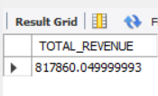

**2. Average Order Value:**

**SELECT sum(total_price) / count(distinct order_id) as Avg_Order_value from pizza_new;**

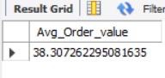

**3. Total Pizza Sold:**

**select sum(quantity) as Total_Pizza_sold from pizza_new;**

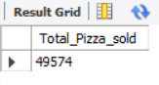

**4. Total Number Of Orders :**

**SELECT count(distinct order_id) as TOTAL_ORDERS from pizza_new;**

**You can use CAST function to show the result in decimal form:**

**select cast(sum(quantity) / count(distinct order_id) as decimal(10,2)) as**

**Average_order from pizza_new;**

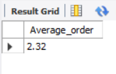

**5. Daily Trend for Total Orders:**

**select dayname(date_column)as order_day, count(distinct order_id) as Total_orders**

**from pizza_new**

**group by dayname(date_column);**

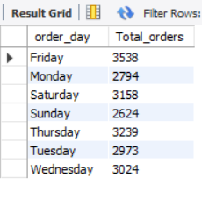

**6. Monthly trend for Total Orders:**

**select monthname(date_column)as Order_month, count(distinct order_id)as Total_orders**

**from pizza_new**

**group by monthname(date_column);**

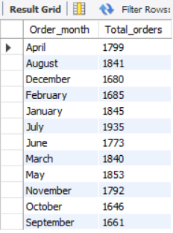

**7. Percentage of Sales by Pizza category:**

**select pizza_category, sum(total_price)*100/(select sum(total_price) from pizza_new)as Percentage**

**from pizza_new**

**group by pizza_category;**

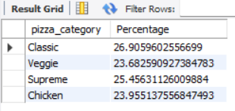

**8. Percentage of Sales by Pizza Size:**

**select pizza_size, sum(total_price)*100/(select sum(total_price) from pizza_new)as Percentage**

**from pizza_new**

**group by pizza_size;**

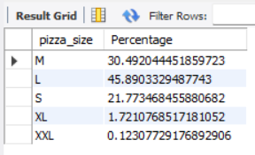

**9. Total Pizza Sold by Pizza Category: also the pizza_name is given**

**select pizza_name,pizza_category, sum(quantity)**

**from pizza_new**

**group by pizza_name;**

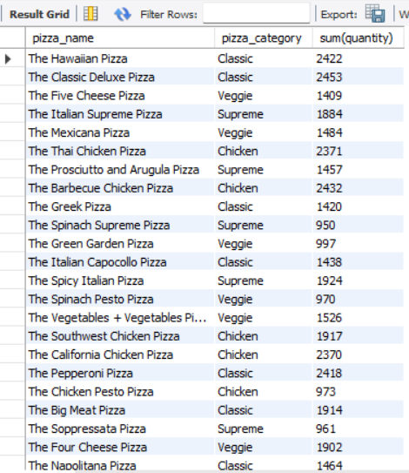

**10. Total 5 best seller by Revenue, Total Quantity and Total Orders:**

**select pizza_name, sum(total_price)as Total_revenue, sum(quantity)as sold_pizzas**

**from pizza_new**

**group by pizza_name**

**order by Total_revenue desc limit 5;**

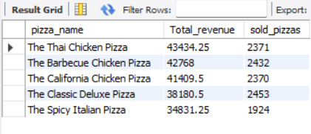

**11. Bottom 5 seller by revenue, quantity and orders:**

**select pizza_name, sum(total_price)as Total_revenue, sum(quantity)as sold_pizzas**

**from pizza_new**

**group by pizza_name**

**order by Total_revenue limit 5;**

